Text Based Game

Story Outline
Story:
- Young person encountering drugs
- different options for story progressions
Genre:
- Horror influences
Situations:
- Party, with different rooms, based on different drugs
- kitchen/alcohol, living room/cannabis, basement/lsd, bathroom/mystery white powder(based on cocaine/amphetamines), bedroom/xanax
- Bad and good endings, based on choices
Character:
- POV
- unknown character
- gender-neutral

Room Plan
map draft by Joey
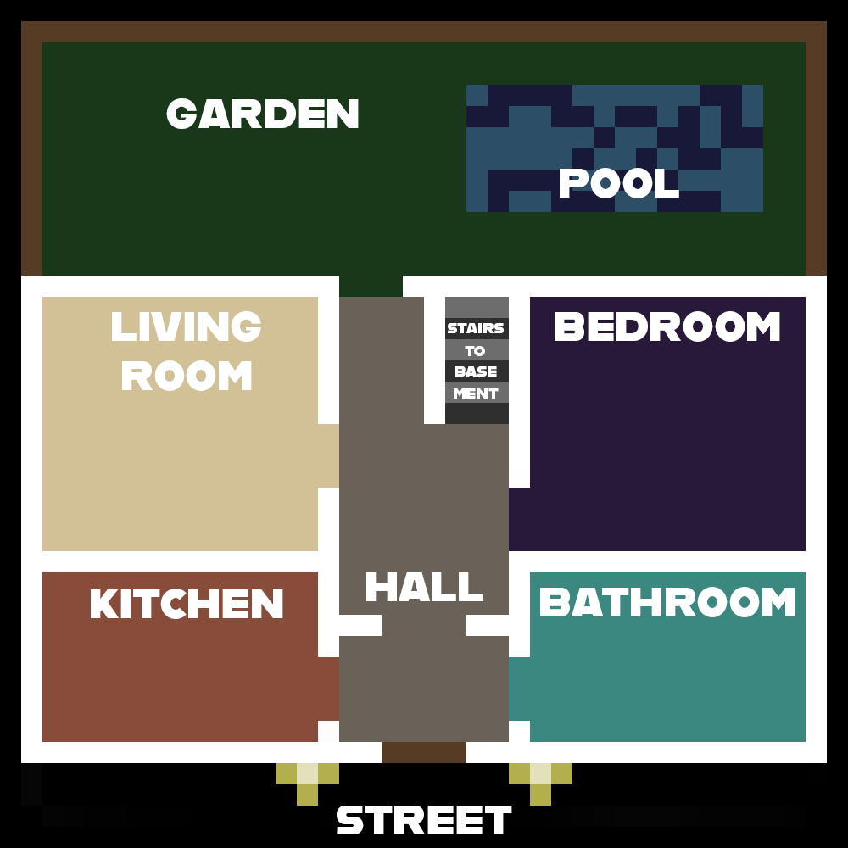

Detailed Story

Room 1 - Street
- parent drops you off talks to you before you leave, tells you be careful and not to drink anything or do drugs

Room Description
“Your dad drove you to a party some friends at school invited you to. You weren't sure if you should go, but they said you’ll have a lot of fun.
You just exited the car and convinced him not to escort you to the front door of the house, as you hear him roll down the window of his car: ‘Be careful, dear. And remember what we talked about - do not drink any alcohol and absolutely no drugs!’”

Objects
- Front Door: “The solid wooden barrier that separates you from the party and your friends. It stands as a threshold between the safety of home and the mysterium of the night ahead of you.”
- Porch Light: “A soft glow emanates from the porch light above, casting a warm and inviting ambiance over the scene.”
- Pathway: “The concrete pathway leads from the car to the row house, guiding your steps as you venture forth.”
- Car: “Your parent's car sits parked in the driveway, a tangible reminder of your dad’s presence.”
- Potted Tree: “A potted palm tree adorns the porch, its long leaves rustle softly in the evening breeze, adding a touch of nature to the suburban neighborhood.”
One can smash the potted tree which triggers the following: “You destroy the potted palm tree and it shatters on the ground, spreading compost all over the floor and the plant sadly lying on the ground.”

People
- Dad: “Your guardian sits in the car, his face etched with a bit of concern as he waits for you to get into the house. His words of advice echo in your mind.”
Dialogue with Dad

Player: Listen, Dad! I’m seventeen. I can take care of myself now.

Dad: Sure you can. I just know how this phase was when I was a teenager.

Player: Yeah I know. “Wanted to try everything, but didnt see the danger of it all
blablabla…” I know all that.

Dad: Since you’re so wise, I’m sure you can resist the temptation and peer
pressure on such parties.

Player: I’ll try my best not to be a disgrace to my poor father.

Room 2 - Hall

Room Description:
“As you enter the hallway, you are greeted by a friend of yours, Jasmine. She’s a year older than you - a plump, dark-haired girl with blue eyes.
She greets you with a happy expression: ‘You made it! To be honest, I didn’t expect to see you here today. Glad you’re here!’
She takes off into the living room, and you are left by yourself in the lovely, old hall. It is a cozy room, with a warm tapestry and you hear loud sounds, music from one of the other rooms.”

- you can go to the kitchen, the living room, the bathroom, the bedroom, use stairs to the downstairs bedroom, the backyard, or go home

Objects
- Jasmine (conversation? introductory to the game/party)
- Mirror (E): "A tall, ornate mirror hangs on the wall, reflecting your image back at you as you enter the hallway. Its antique frame adds a touch of elegance to the cozy surroundings."
- Chandelier: "A vintage chandelier hangs from the ceiling, casting a soft, warm glow over the hallway. It wiggles a bit with the beat of the music from another room."
- Coat Rack (E): "A sturdy coat rack stands near the entrance, filled with some jackets and coats."
- Shelves (N):
Pictures: "A collection of family pictures lines the walls, capturing what seems to be a ski vacation for Jasmine and her family. It makes you think that she seems a lot more mature now.”
Candles (lit): smell them
- Shoe Rack (S) : make an observation that leads to questioning Jasmine if you should take off your shoes (answer no)
- Stairs( W): Make an observation for now, if you try to go down at this point, Jasmine pulls you and says, let's go inside first
- The main door is currently to your South
- North East to exit the hallway, and then North for the living room, East for the kitchen, and North East for the backyard

Narrative:
After entering the house, Jasmine gives you a hug and greets you.
Jasmine: Hi! You finally showed up. I was starting to think, that you were going to ditch
me here like you always do.

Player: Hello to you too, and what do you mean, like I always do? This is the only
time I agreed to come to one of these parties. Remember?

Jasmine: Alright, alright, I’m too good for the crowd, let’s take your coat off and go
inside.

Player: From the smell of alcohol, I can already tell I’m going to „like“ it.

Jasmine: Oh, that’s right. You’ve never been drunk. Maybe we can change your mind
tonight.

Jasmine: And, by the way, you know who is here. Maybe she/he can help you loosen
up tonight

Player: Can we not talk about her/him right now?

Jasmine: Okay, but promise me you are going to do something about it tonight

Player: 1. I promise! 2. I make no such promises.

Optional conversation options with Jasmine:
Player: (after noticing the Shoe rack) Do I have to take my shoes off?

Jasmine: Honestly, under which rock have you been living until now? No, it’s a party,
you don’t take your shoes off at a party.

Player: (after noticing the pictures on the shelves) Nice pictures! Wow, how long has
it been since you guys went on this ski trip?

Jasmine: I’m not sure, but it has been a few years, I guess.

Player: You look way younger here.

Player: (after choosing to go down the stairs)

Jasmine: Let’s not go down the stairs, you probably won’t enjoy the guys that are
currently there.

Player: And how are you so sure about that?

Jasmine: I know; just take my word for it.

Player: Ok

Jasmine: C'mon, let’s go inside

Room 3 - Kitchen (Parsa)

Room Description:
The kitchen is a lively space with a rectangular island at its center, surrounded by counters along three walls. The room is filled with the sounds of loud but tolerable music and the chatter of people taking shots and having fun. As you enter, the smell of strong alcoholic drinks fills the air. The island counters are crowded with various drinks and paper cups. Four seats are occupied by partygoers. You are offered a variety of drinks, each with different effects on your sobriety points. The kitchen is bustling with activity, and you can choose to participate or explore.

Player Actions and Consequences:
- Stay and Engage with the Party:
  - Decline a Drink:
    - Consequences: You observe drunk people doing dumb stuff.
  - Choose a Drink:
    - Drink Options: Each drink affects sobriety points differently and the effects stack.
    - Consequences: If you get too drunk, you will throw up on everyone.
- Engage in a Drinking Game:
  - Rules and Outcomes: Performance in the game affects sobriety points and interactions with others.
  - Consequences: Winning the game increases social status among partygoers; losing might lead to negative consequences.
- Intervene with an Intoxicated Person:
  - Notice Someone Getting Dangerously Intoxicated:
    - Options for Intervention:
      - Offer Water: Helps them recover a bit.
      - Suggest They Sit Down: Prevents them from getting worse.
      - Alert a Friend: Gets someone else to help.
    - Consequences: Reactions vary from gratitude to annoyance.
- Search for Non-Alcoholic Beverages or Snacks:
  - Explore the Fridge:
    - Find and choose from alcoholic and non-alcoholic drinks.
    - Discover hidden items or information.
  - Coffee Maker and Mug Rack:
    - Make a coffee to sober up.
  - Brewer & Smoothie Maker:
    - Observation only.
  - Microwave, Stoves, Utensil Holder, Knife Block Set, Dishwasher, Sink:
    - Observation only.
  - Plant:
    - Look at or touch for a simple interaction.
  - Shelf with Luxurious Alcohol Collection:
    - Observation only; glass door is locked.

Interactive Objects and Details:
- Drinks (C): A large collection of different drinks and paper cups covering the island counters.
- Seats (C): Four seats on two sides of the island counter, currently taken.
- Garbage Can (NW): Throw away items like cups.
- Windows (N & S): Blinds down. Option to pull up, but an NPC will advise against it to avoid neighbor complaints about underage drinking.
- Fridge (NE): Open to find alcoholic and non-alcoholic drinks.
- Coffee Maker (NE): Can make coffee if you have a mug.
- Brewer & Smoothie Maker (NE): Observation only.
- Microwave (E): Observation only.
- Stoves (E): Observation only.
- Paper Towel (E): Grab one.
- Utensil Holder (SE): Observation only.
- Knife Block Set (SE): Observation only.
- Plant (SE): Look at or touch.
- Coffee Mug Rack (SE): Grab a mug.
- Dishwasher (SE): Observation only.
- Sink with Hand Sanitizer (SE): Wash hands.
- Plant (S): Look at or touch.
- Shelf (SW): Luxurious shelf with a locked glass door containing an expensive alcohol collection.

Dialogues Between the Player and the NPCs
Player Enters the Kitchen
NPC 1 (Handing Out Drinks):
- NPC 1: "Hey! Want a drink? We've got everything here!"
  - Options:
    - Player: "Sure, I'll take a drink."
      - NPC 1: "Great! What'll it be? We've got beer, vodka, whiskey, and more."
    - Player: "No thanks, I'm good."
      - NPC 1: "Suit yourself, but you're missing out!"
Player Chooses a Drink
NPC 2 (Pouring Shots):
- NPC 2: "Here's to a great night! Bottoms up!"
  - Player: "Cheers!"
    - NPC 2: "Watch out, this stuff hits hard."
Player Declines a Drink and Observes
Observing Drunk People:
NPC 3 (Dancing on the Counter):
- NPC 3: "Look at me, I'm flying!"
  - Player: (Laughs) "Careful up there!"
    - NPC 3: "Don't worry, I've got this!"
Player Notices Someone Getting Dangerously Intoxicated
NPC 4 (Stumbling Around):
- NPC 4: "I don't feel so good..."
  - Options:
    - Player: "Here, have some water."
      - NPC 4: "Thanks, I needed that."
    - Player: "Maybe you should sit down."
      - NPC 4: "Yeah, that's probably a good idea."
    - Player: "Let me get your friend to help you."
      - NPC 4: "Thanks, you're a lifesaver."
Player Searches for Non-Alcoholic Beverages or Snacks
Exploring the Fridge:
NPC 5 (Reaching for a Drink):
- NPC 5: "Need a drink? There's some soda in the back if you're not into alcohol."
  - Player: "Thanks, I think I'll grab a soda."
    - NPC 5: "No problem, enjoy!"
Player Engages in a Drinking Game
NPC 6 (Organizing the Game):
- NPC 6: "Alright, who’s up for a drinking game? The rules are simple: last one standing wins!"
  - Options:
    - Player: "Count me in!"
      - NPC 6: "Alright, let's get started! First round: take a shot!"
    - Player: "Maybe next time."
      - NPC 6: "Your loss! We're having a blast over here."
Player Interacts with Objects
Coffee Maker:
- Player: "I could use some coffee."
  - NPC 7 (By the Coffee Maker): "You'll need a mug. There are some over on the rack."
    - Player: "Got it, thanks."
Shelf with Luxurious Alcohol Collection:
- Player: "What's in that shelf?"
  - NPC 8: "Oh, that's the host's prized collection. It's locked up tight."
Windows:
- Player: "Should I pull these blinds up?"
  - NPC 9: "Better not. The neighbors might call the cops if they see underage drinking."

Room 4 - Living room (Parsa)

Room description:
The living room is a cozy, inviting space where people are gathered in a circle. Some are sunken into the plush, brown leather couches, while others are sitting or lying on the floor. The room has a warm, relaxed atmosphere, enhanced by the soft lighting from a lampstand near the chimney and the soft music playing from a stereo system below the wall-mounted TV.

Player actions and consequences
- Accept the Invitation to Sit:
  - Hit the Bong:
    - Consequences: You start coughing violently, get dizzy, and everything seems to slow down. You feel confused and struggle to perform simple tasks.
  - Decline and Just Hang Out:
    - Observe People: You notice the relaxed, almost sloth-like behavior of the attendees.
    - Help Anxious Person:
      - If someone starts panicking, you can help them calm down.
      - Options for Helping:
        - Talk to Them Calmly: Provides extra sobriety points.
        - Offer Water: Helps them relax but doesn't provide sobriety points.
        - Suggest Breathing Exercises: Provides extra sobriety points.
        - Distract with a Joke or Story: Helps them relax but doesn't provide sobriety points.
- Explore Conversation Options:
  - Different Party Attendees:
    - Person 1: Shares a story about the last party, revealing a hidden stash of snacks in the room.
    - Person 2: Talks about their favorite books, hinting at a particular book on the bookshelf that contains a secret.
    - Person 3: Mentions a spontaneous game that people sometimes play in the living room.
- Explore the Room and Interact with Objects:
  - Coffee Table:
    - Check the empty space under the table to find a hidden key.
  - Rug:
    - Lift the rug to discover a small, hidden compartment with a note inside.
  - Bookshelf:
    - Find a book that, when pulled, reveals a hidden compartment.
  - Stereo:
    - Adjust the music, finding a secret CD with a hidden message.
  - Clock:
    - Inspect the old clock to find an ancient, mysterious item inside.
  - Chimney:
    - Check the chimney to discover a hidden stash of party supplies.
  - Lampstand:
    - Move the lampstand to reveal a hidden switch for mood lighting.
  - Seats:
    - Inspect the seats to find hidden compartments under the cushions.
- Participate in Spontaneous Activity or Game:
  - Activity/Game Options:
    - Charades: Winning provides extra sobriety points; losing makes you slightly dizzy.
    - Truth or Dare: Consequences depend on the choices made during the game.
    - Card Game: Winning can provide insights about other characters; losing might reveal embarrassing secrets.

Objects:
- Coffee Table (C): Light-colored wooden table with glass covering on top. Below the top side is an empty space.
- Rug (C):
- Couches (C): Three large brown leather couches surround the coffee table in the middle
- TV (W): The TV is hanging on the wall. turned off.
- Stereo (W): Right below the TV is a huge stereo system that is currently playing music.
- Clock (SW): in the corner of the room is an old, big standing clock.
- Chimney (NE): a gorgeous chimney in the corner of the room
- Bookshelf (NE): a bookshelf standing right next to the chimney, filled with many books from different genres.
- Lampstand (NE): a lamp next to the chimney, with dim light that is just enough to cover the area around the chimney
- seats (NE): two seats placed in front of the chimney. the seats are set, with the couches on the other side of the room.

Dialogues Between the Player and the NPCs
Player Accepts the Invitation to Sit
NPC 1 (Sitting on the Couch):
- NPC 1: "Hey there! Join us, there's plenty of room. Want a hit from the bong?"
  - Options:
    - Player: "Sure, why not."
      - NPC 1: "Alright, here you go. Just take it slow."
    - Player: "No thanks, I'll just hang out."
      - NPC 1: "No worries, just chill with us."
Player Declines the Bong and Just Hangs Out
Observing the Room:
Player Notices Someone Getting Anxious (NPC 2)
NPC 2 (Sitting on the Floor, Looking Anxious):
- NPC 2: "Oh man, I think I'm freaking out. My heart is racing."
  - Options:
    - Player: "Hey, it's okay. Just breathe with me. In and out, slowly."
      - NPC 2: "Okay, okay. I'll try... Thanks, that helps."
    - Player: "Here, have some water. It might help."
      - NPC 2: "Thanks. Water helps a bit."
    - Player: "Want to hear a funny story? It'll take your mind off things."
      - NPC 2: "Yeah, sure. That sounds good."
    - Player: "Try this breathing exercise with me. It'll calm you down."
      - NPC 2: "Alright, I'll give it a shot... That actually works. Thanks."
Exploring Conversation Options
Talking to Different Party Attendees:
NPC 3 (Leaning Against the Couch):
- NPC 3: "This party's pretty chill, huh?"
  - Player: "Yeah, it's nice. What's the last party you went to like?"
    - NPC 3: "Oh man, it was wild. We had a secret stash of snacks hidden under the coffee table here. I think there's still some left."
NPC 4 (Browsing the Bookshelf):
- NPC 4: "Hey, do you like to read?"
  - Player: "Yeah, I do. Got any recommendations?"
    - NPC 4: "Absolutely. There's this one book here that's got a secret compartment. See if you can find it."
NPC 5 (Setting Up a Game):
- NPC 5: "We're about to start a game of charades. Want to join?"
  - Player: "Sure, that sounds fun."
    - NPC 5: "Awesome! Let's see if you can guess this one."
Exploring the Room and Interacting with Objects
Interacting with Objects:
Coffee Table:
- Player: "What's this under the glass cover?"
  - NPC 3: "Oh, that's a hidden key. It's for a secret stash somewhere in the room."
Rug:
- Player: "There’s something under this rug..."
  - NPC 4: "You found it! That's a hidden compartment with a note. Wonder what it says?"
Bookshelf:
- Player: "Which book did you say had a secret?"
  - NPC 4: "It's the one with the blue cover. Pull it out and see what happens."
Stereo:
- Player: "Can I change the music?"
  - NPC 5: "Sure, go ahead. Just be careful with the CD labeled 'Secret Mix'. It has a hidden message."
Clock:
- Player: "This old clock looks interesting."
  - NPC 3: "Check inside it. There's something ancient and mysterious in there."
Chimney:
- Player: "What's up with the chimney?"
  - NPC 5: "Look closely. There's a hidden stash of party supplies."
Lampstand:
- Player: "This lampstand feels out of place."
  - NPC 4: "Try moving it. There's a hidden switch for mood lighting."
Seats:
- Player: "These seats look comfy."
  - NPC 2: "They are. Also, check under the cushions. You might find something interesting."
Participating in a Spontaneous Activity or Game
Charades Game:
NPC 5 (Game Organizer):
- NPC 5: "Alright, you're up! Here's your charade clue."
  - Player: "Okay, I'll give it my best shot."
    - After the player performs:
      - NPC 3: "That was awesome! You nailed it."
      - NPC 4: "Better luck next time, you'll get it."
Truth or Dare Game:
NPC 3 (Game Organizer):
- NPC 3: "Truth or dare?"
  - Player: "Truth."
    - NPC 3: "What's the most embarrassing thing you've ever done?"
  - Player: "Dare."
    - NPC 3: "I dare you to dance like no one's watching."
Card Game:
NPC 5 (Game Organizer):
- NPC 5: "We're starting a card game. You in?"
  - Player: "Yeah, deal me in."
    - After the Game:
      - NPC 3: "Nice win! You played really well."
      - NPC 4: "Good game. Maybe next time I'll win."

Room 5 - Bedroom

Room Description:
“As you step into the bedroom, you find yourself in a hushed atmosphere, with several figures sprawled across beds, appearing to be asleep. Among them, one person is awake, their eyes heavy with drowsiness. They extend a small pill towards you, offering it with a faint smile. The room is dimly lit, casting shadows that dance across the walls, and the air carries a faint scent of something sweet and musky.”
Objects:
Xanax Pill (E): "A small, white pill rests in the palm of the awake person's hand, offering it to you with a serene expression."
Beds (N): "Several beds occupy the room, each with a figure lying upon them, seemingly lost in slumber."
TV (W): "A television sits in the corner of the room, its screen displaying a mundane program, with no remote in sight."

Conversation Option:
"The awake person looks at you with a knowing gaze, hinting at the possibility of a private conversation.“

Awake Person: Hey, I noticed you standing there. You seem a bit lost. Care for a chat?
Player: Uh, sure. What’s on your mind?
Awake Person: Just life, I guess. You ever feel like you’re drowning, but everyone around you thinks you’re swimming just fine?
Player: Yeah, sometimes.
Awake Person: It’s tough, you know? Trying to keep it together when everything feels like it’s falling apart. That’s why I take these.
Player: Those... those are xanax, right?
Awake Person: Yeah, they help me cope. But sometimes, I think they’re just dragging me deeper.
Player: Have you tried talking to someone about this? Getting help?
Awake Person: I’ve thought about it. But it’s not easy admitting you have a problem, you know?
Player: I understand. But ignoring it won’t make it go away. You deserve to feel better.
Awake Person: Maybe you’re right. Thanks for listening, I appreciate it.
Player: Anytime. And if you ever need someone to talk to, I’m here.

(gains sober points for this conversation, looses sober points for taking the pill)

Room 6 - Bathroom - Tutorial

Room 7 - Basement

Room description:
“You descend into the basement, where the thumping bass of the music becomes almost tangible, pulsating through the air. The room is alive with movement, bodies swaying to the rhythm in the dimly lit space.”

Objects:
- Couch: “Positioned in a corner of the basement, the couch is worn but comfortable, where Clip, a young guy you’ve vaguely met before, sits.”
- Blotter Paper (held by Clip, player can take it after offer): “A small square of paper adorned with intricate patterns."
- Boom Box: “Positioned in a corner, the boom box blasts rhythmic beats that pulse through the basement, setting the energetic atmosphere for the party.”
- Old Rug: “Spread across the cold concrete floor, an old rug provides a semblance of comfort in the otherwise stark basement. Its faded colors and frayed edges bear the marks of countless parties.”
People:
- Clip “A twenty year old man with a blonde buzzcut and bright green eyes. He smells of cigarettes and energy drinks. He smiles back at you as you look at him.”

Choice offer:
“In the midst of all the people dancing and singing, you see a tall guy with a buzzcut - he introduces himself as ‘Clip’. He holds out his hand and reveals a small square of paper. He extends it towards you. With a grin he says: ‘This will change your life.’ Your decision hangs in the balance - to accept or reject?”

Acceptance
“You put the paper under your tongue as instructed by Clip. After a short period of time, reality warps around you, colors bleeding into one another, and the music morphing into a symphony of chaos. It's a journey into the recesses of your mind, but one fraught with peril:
Colors pulsate with an overwhelming intensity, morphing into surreal shapes that dance before your disbelieving eyes. Every sound becomes a discordant chaotic noise, echoing endlessly. Paranoia grips your thoughts, the shadows seem to be attacking you from everywhere, they flicker and dance, morphing into grotesque forms that seem to mock your terror. You fall unconscious.”

Rejection
“You hang out with Clip for a while but he seems a bit zoned out after a while. It’s as if he’s been plunged into a nightmare. Suddenly, his eyes widen with fear making you uncomfortable. You want to stand up and leave but your mind in empathy for Clip is shouting: ‘What is happening?!’ His eyes are now darting frantically around the room as if searching for escape from unseen terrors. He jumps up from the couch, jerky and erratic. What do you do?”

Choice offer:
“Do you want to help Clip?”

Acceptance
“You drag Clip to the garden to get a calmer and more quiet environment for him. You sit him down on the floor and reassure him that everything is going to be fine. You try calming him down by doing some breathing exercises and bringing him a glass of water from the kitchen. It helps him a lot.”
- earns sobriety points
- teleports player into the garden

Rejection
“You leave the cellar and lock out the music as you shut the cellar door behind you. You hear a muffled scream from downstairs - you’re sure of it - it was Clip.”
- subtracts sobriety
- puts player into the hall again

Room 8 - Garden
- when you go into the backyard, you see someone puking in a bush
- you can either go and help them or ignore it (earns 1 sobriety points hab ich schon declared), decision logik kannst ausm basement klauen
- you are offered different options for helping them, with different effects optional wenn du bock hast
- there is a pool which you can jump into, or just sit at watching the water
- if sobriety <= 4 you just get out or decide to take a swim (again decision mechanic)
- if sobriety <= 2, you will fall into the pool, you might get saved (vielleicht 20 prozent chance?)
- if you have <= 1 sobriety, you drown
- the same rules apply if you jump into the pool willingly

Ending (refactor)
- if you decide to leave the party, you say goodbye to your host and others
- the ending depends on your sobriety points
- if you have 5 points of sobriety a friend comes over and asks to walk home with you, they tell you the party was a bit much and they are glad that you are strong enough to not get pressured into anything stupid
- if you have 4 points of sobriety, one of your friends gives you a sandwich and a big hug and asks to walk you home, if you accept they tell you bad jokes and you get home safe, if you decline you trip on the way and scrape your knee pretty bad (ouch)
- if you have 3 points of sobriety one of your friends asks if they should call your parents to come pick you up, you get home safe, if you decline you throw up on the way home and see your crush going home with someone else
- if you have 2 points of sobriety, your parents are already there to pick you up. luckily one of your friends called them to come get you (only if you helped someone at least once) otherwise you get a taxi and throw up all over it. the taxi driver makes you pay a super high cleaning fee and your parents are really mad
- if you have <= 1 point of sobriety, you trip on your way out and hit your head on the ground, you hear you friends scream, you wake up in the hospital

